Changes document for MS Decom activities

Project: Z_FD45_QSPL_REQ

System : xFE

CD: 151938.

Transport request: DFEK962733

—---------------------------------------------------------------------------------------------------------------------------------

1. Adding a new button as Export to my Drive in Request view.

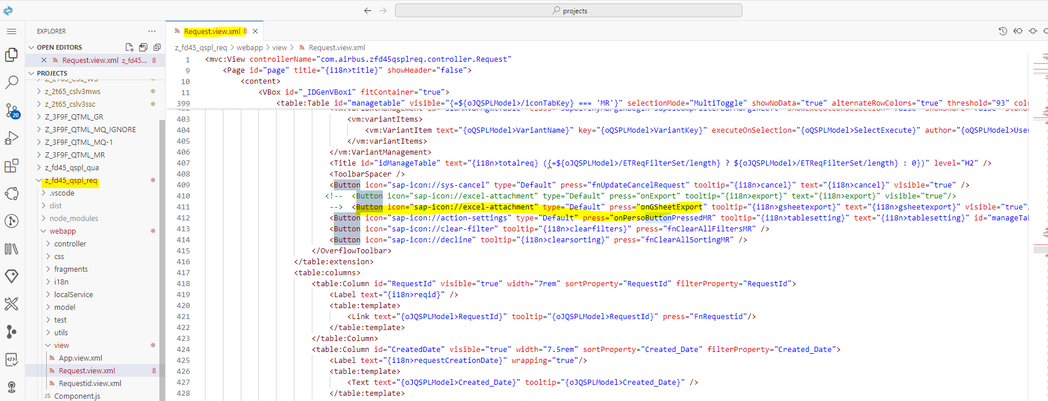

1. Below logic to fetch the data based on the filters from odata service and export it to google sheet.

